

Harvel-Electric

Details

Batch Code: 1807G

Group Members

1: M Awais Student1124953
2: Shafqat Ali Student1124962
3: Zeeshan Ali Student1125885

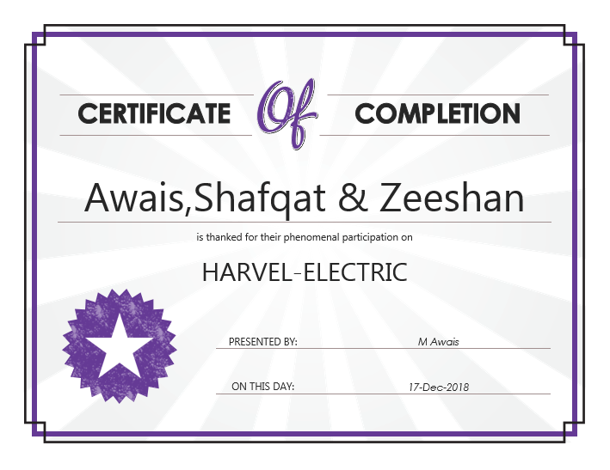

Index

- Introduction
- Objectives
- Problem Statement
- Hardware/ Software Requirements

Introduction

The thirst for learning, upgrading technical skills and applying the concepts in real life environment at a fast pace is what the industry demands from IT professionals today. However busy work schedules, far-flung locations, unavailability of convenient time-slots pose as major barriers when it comes to applying the concepts into realism. And hence the need to look out for alternative means of implementation in the form of laddered approach.

The above truly pose as constraints especially for our students too! With their busy schedules, it is indeed difficult for our students to keep up with the genuine and constant need for integrated application which can be seen live especially so in the field of IT education where technology can change on the spur of a moment. Well, technology does come to our rescue at such times!!

Keeping the above in mind and in tune with our constant endeavour to use Technology in our training model, we at Aptech have thought of revolutionizing the way our students learn and implement the concepts using tools themselves by providing a live and synchronous eProject learning environment!

So what is this eProject?

eProject is a step-by-step learning environment that closely simulates the classroom and Lab based learning environment into actual implementation. It is a project implementation at your fingertips!! An electronic, live juncture on the machine that allows you to

- Practice step by step i.e. laddered approach.
- Build a larger more robust application.
- Usage of certain utilities in applications designed by user.
- Single program to unified code leading to a complete application.
- Learn implementation of concepts in a phased manner.
- Enhance skills and add value.
- Work on real life projects.
- Give a real life scenario and help to create applications more complicated and useful.
- Mentoring through email support.

The students at the centre are expected to complete this eProject and send complete project along with the documentation to eprojects@aptechfze.ae

Looking forward to a positive response from your end!!

Objectives of the project

The Objective of this program is to give a sample project to work on real life projects. These applications help you build a larger more robust application.

The objective is not to teach you JavaScript/Dreamweaver but to provide you with a real life scenario and help you create basic applications using the tools.

You can revise the chapters before you start with the project.

This project is meant for students who have completed the module of Dreamweaver. These programs should be done in the Lab sessions with assistance of the faculty if required.

It is very essential that a student has a clear understanding of the subject. Students should go through the project and solve the assignments as per requirements given.

Kindly get back @ eprojects@aptechfze.ae in case of any doubts regarding the application or its objectives.

Problem Statement

Harvel Electric is selling various electrical products. The company advertises by distributing the pamphlets, advertising on television and so on. Due to rapid development in internet field, the company decides to launch a website where people will get all the information about the various products available with them easily.

Requirement Specification:
The Web site is to be created based on the following requirements.

- The Home Page should be created making use of Sections with a suitable logo
- The site should display a menu which will contain the options for brief introduction about the various products available, location of the shop and any other information if required.
- The information should be categorized according to different type of products like if a User wants to see only ‘FANS’ then he click on a Link/button/menu etc and he will see different type of FANS. Similarly for ‘GEYSERS’, ‘CFL’ and other products
- When a user selects any product type, a list of products for that product type will be displayed.
- A brief summary of features of individual products should be displayed on the Web Page along with the product but detailed Features should be stored in Individual Word documents which can be downloaded or viewed by the User who wishes to see the same.
- Price List should be available for download.
- There should be a “Contact Us” page which will have the Address of the Company which is as follows and the mail address which when clicked will invoke the local mail client from where they can send an email.

Hardware/ Software Requirements

Hardware
- A minimum computer system that will help you access all the tools in the courses is a Pentium 166 or better
- 64 Megabytes of RAM or better

Software
- Notepad/HTML editor
- Dreamweaver
- IE 5.0/ Netscape 6.0

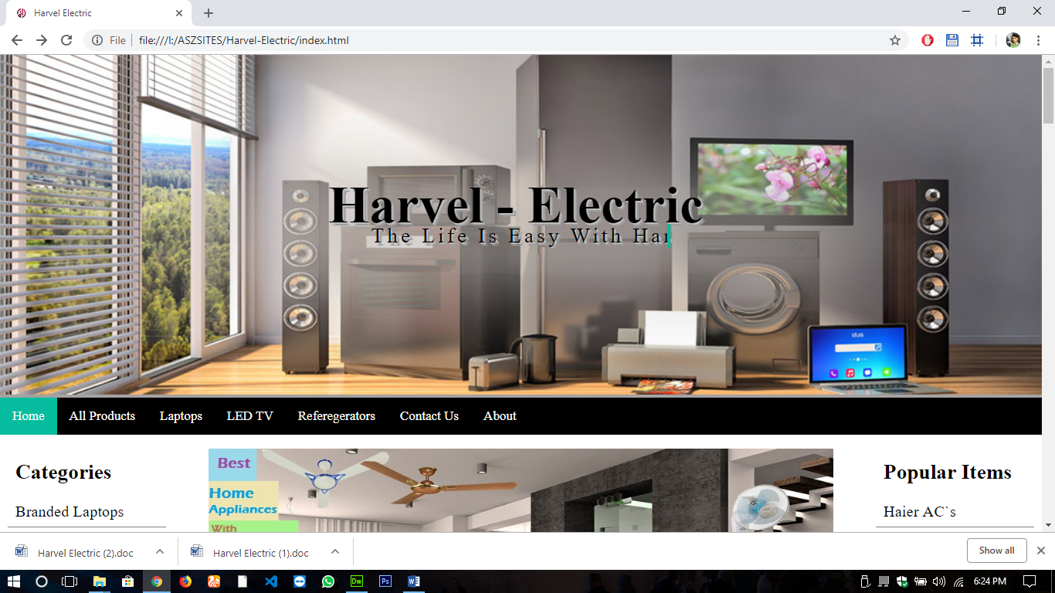
Navbar HTML:

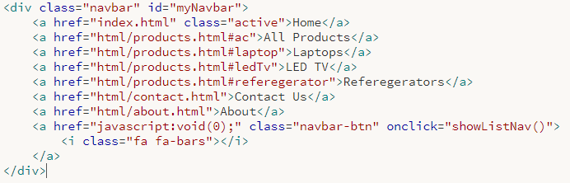
Navbar CSS:
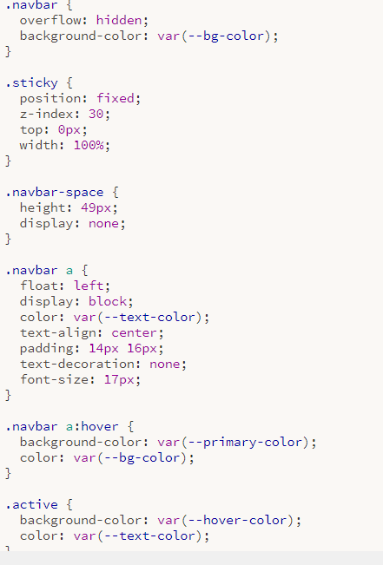

Logo

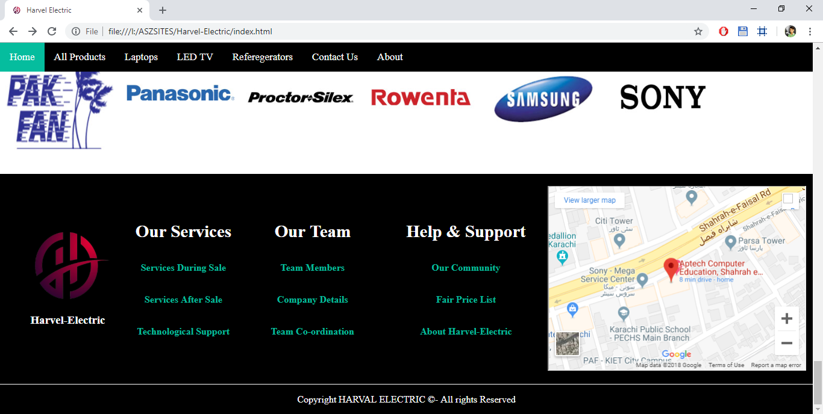

Logo HTML:

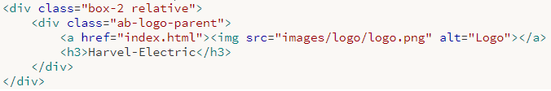

Logo CSS:
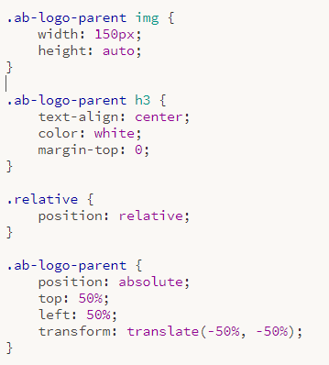

Slider

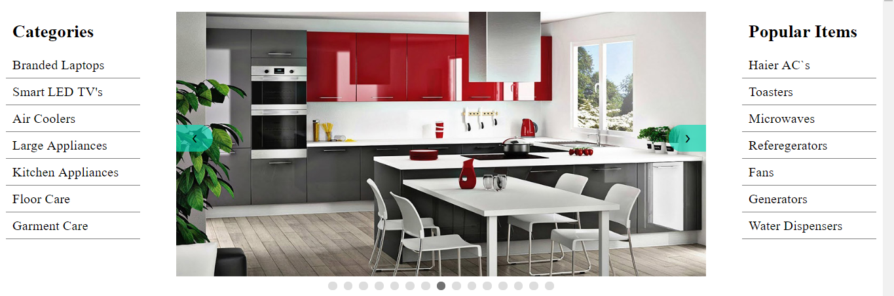

Slider HTML:

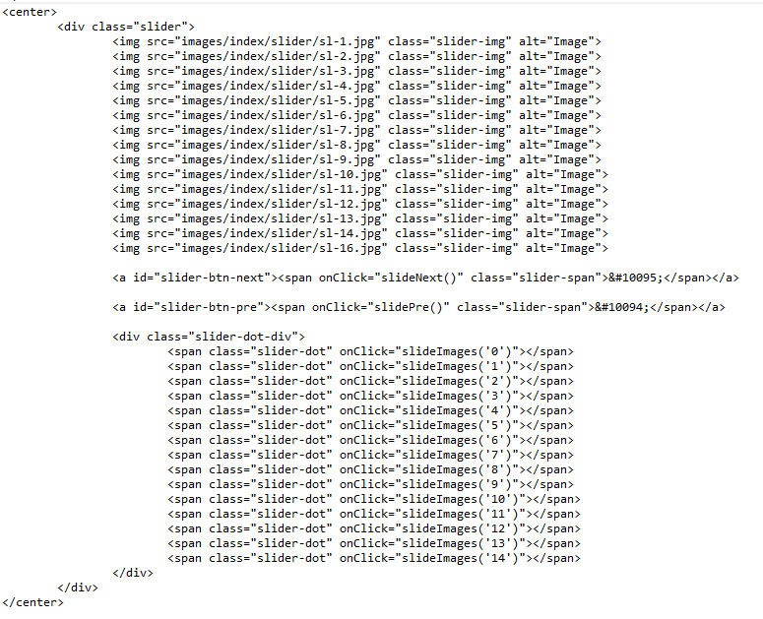

Slider CSS:

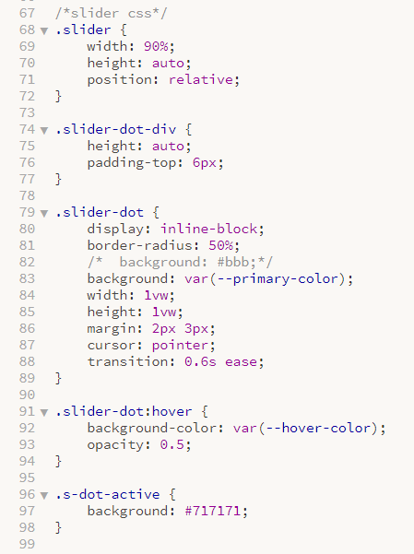

Slider JS:

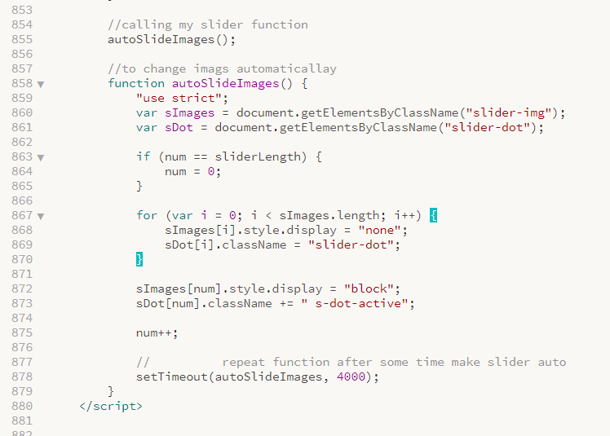

Product Page

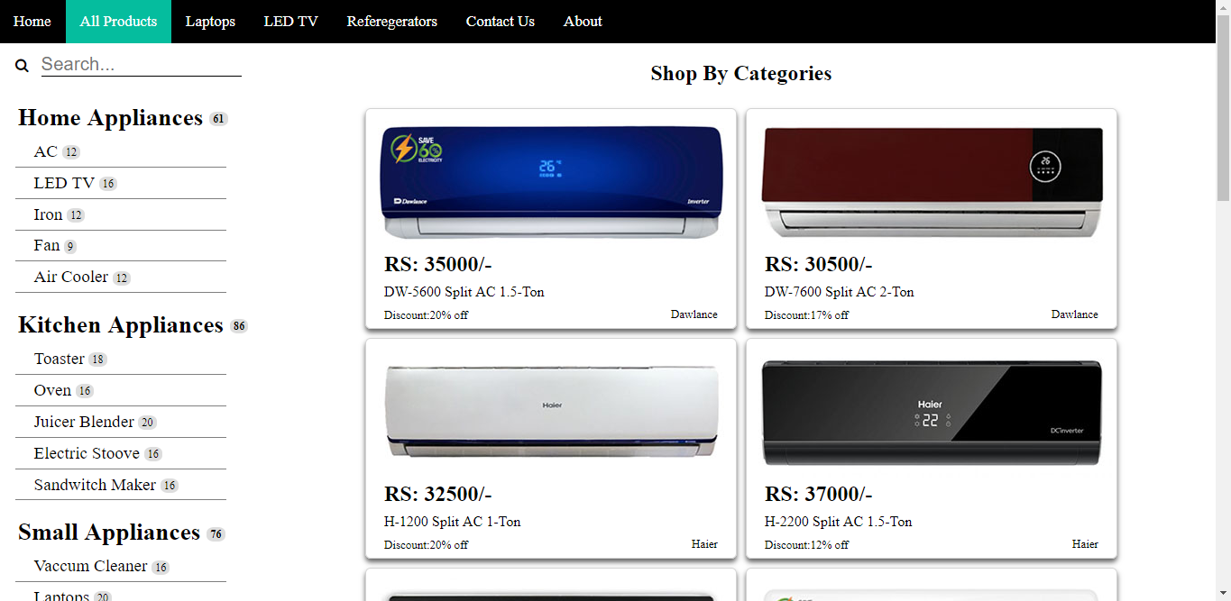

List HTML

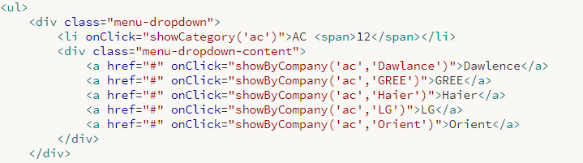

List CSS:

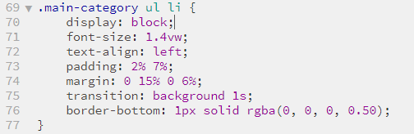

Contact Page

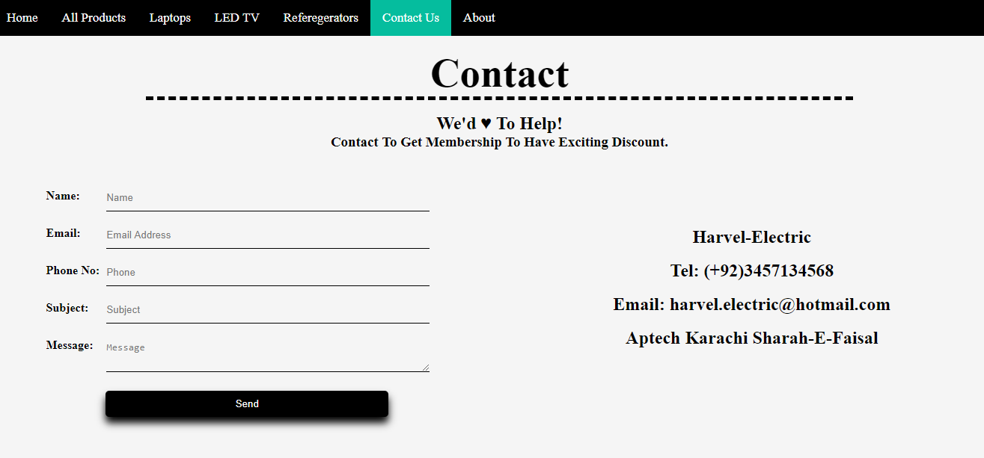

Contact HTML:
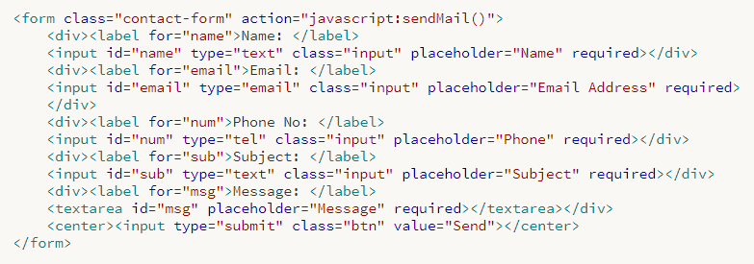

Contact CSS:
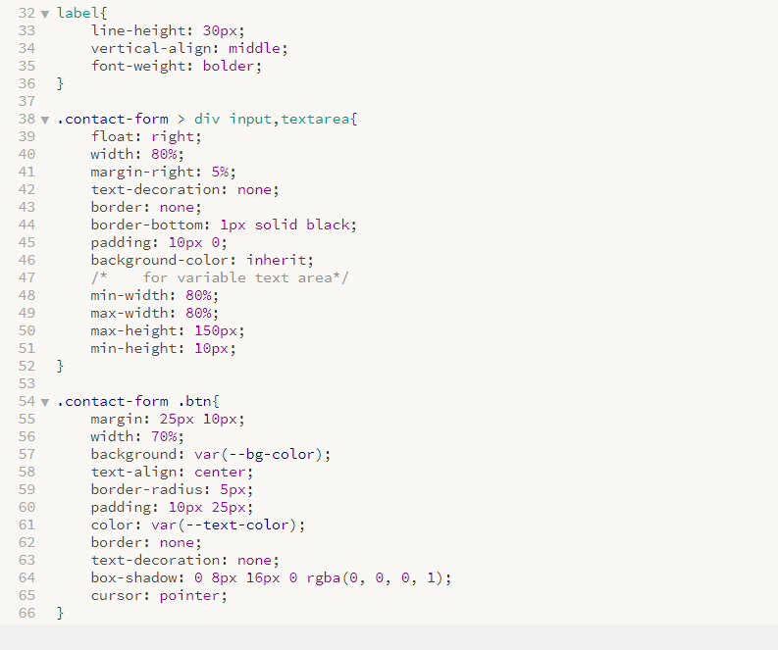

Contact Js:
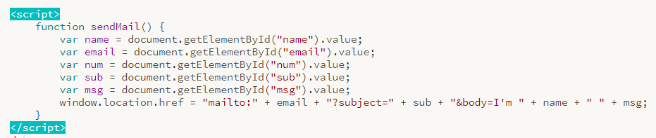

THANKS & BEST REGARDS

